ON DEMAND SECURITY SYSTEM

Submitted By
GROUP-04
ADRITA RAHMAN BUSHRA 20-43367-1
MD. NAFIS ULFAT 20-42248-1
MD. MUZAHIDUL ISLAM 20-43841-2
TAZIN ALAM 20-43848-2

Class Diagram
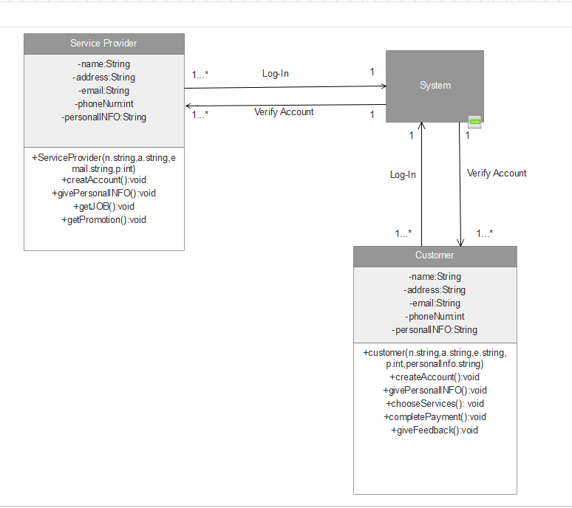

CRC

Class name: Service Provider
Subclasses:
Superclasses:
Responsibilities | Collaborators
gives personal information (name, email, NID, parents’ info, address)
Gives location information
Selected by customer
Get promotion

Class name: Customer
Subclasses:
Superclasses:
Responsibilities | Collaborators
gives personal information (name, email, NID, parents’ info, address)
Gives location information
Choose services (security, baby-sitting, delivery)
Pay service charge
Give feedback about services

